1. **Servlet Introduction:**

* **Servlet** technology is used to create web application (resides at server side and generates dynamic web page).
* **Servlet** technology is robust and scalable because of java language.
* Before Servlet, CGI (Common Gateway Interface) scripting language was popular as a server-side programming language.
* But there was many disadvantages of this technology.

**What is a Servlet?:**

* Servlet is a technology i.e. used to create web application.
* Servlet is an API that provides many interfaces and classes including documentations.
* Servlet is an interface that must be implemented for creating any servlet.
* Servlet is a class that extends the capabilities of the servers and responds to the incoming requests. It can respond to any type of requests.
* Servlet is a web component that is deployed on the server to create dynamic web page.
* There are many interfaces and classes in the servlet API such as Servlet, GenericServlet, HttpServlet, ServletRequest, ServletResponse etc.

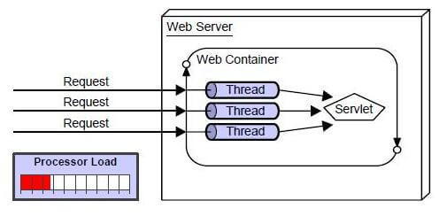

**Disadvantages of CGI:**

* If number of clients increases, it takes more time for sending response.
* For each request, it starts a process and Web server is limited to start processes.
* It uses platform dependent language e.g. C, C++, perl.

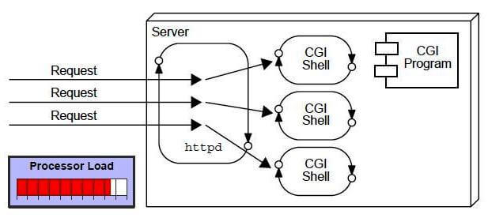

**Advantage of Servlet:**

* There are many advantages of servlet over CGI.
* The web container creates threads for handling the multiple requests to the servlet.
* Threads have a lot of benefits over the Processes such as they share a common memory area, lightweight, cost of communication between the threads are low.
* **Better performance:** because it creates a thread for each request not process.
* **Portability:** because it uses java language.
* **Robust:** Servlets are managed by JVM so we don't need to worry about memory leak, garbage collection etc.
* **Secure:** because it uses java language